
MATHS METHODS 3 & 4
TRIAL EXAMINATION 2
SOLUTIONS
2018

SECTION A – Multiple-choice answers

- B 9. A 17. B
- D 10. E 18. D
- B 11. A 19. C
- E 12. B 20. E
- D 13. D
- A 14. C
- E 15. C
- C 16. A

SECTION A – Multiple-choice solutions

Question 1
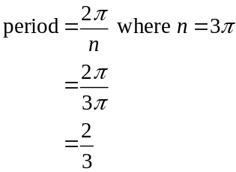
The range of 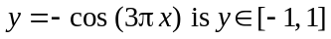.
The range of 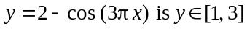.
The answer is B.
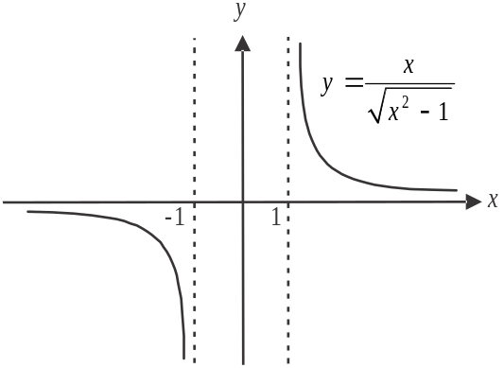
Question 2
Sketch the graph of 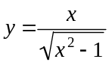.
Factorising gives 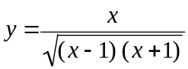.
Asymptotes occur at 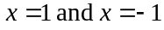.
The function is not defined for .
The domain is 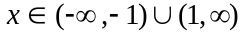.
The answer is D.

Question 3
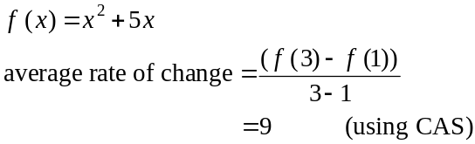
Note, if you got 21 as your answer you forgot to include the brackets in the numerator of the fraction when putting it into your CAS. Beware of this mistake!
The answer is B.
Question 4

Express the simultaneous equations as a matrix equation.
So 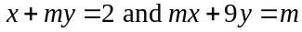 can be expressed as
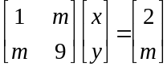
No solutions or infinitely many solutions exist when
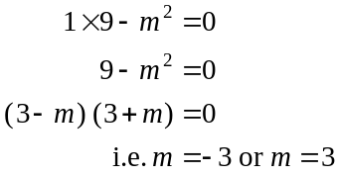
So a unique solution exists for all other values of m i.e. for 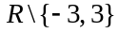.
The answer is E.

Question 5

6 green, 8 yellow
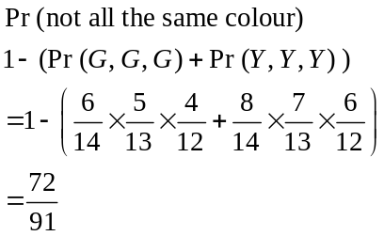
The answer is D.

Question 6

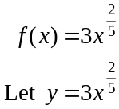
After a reflection in the x-axis, it becomes
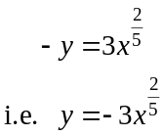
After a dilation by a factor of two from the x-axis it becomes
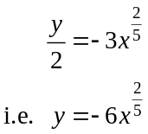
After a translation of four units to the left it becomes 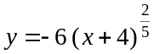.
The answer is A.
Question 7

Let 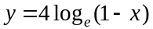.
Swap x and y for inverse.
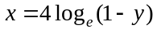
Solve for y using CAS
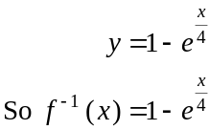
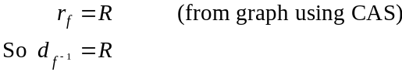
The inverse function is 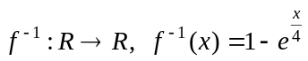.
The answer is E.

Question 8

The sample proportion is given by .
We see from the way the formula for a confidence interval is constructed i.e.
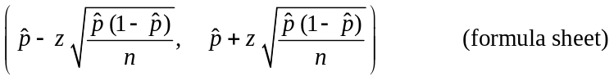
that must be in the middle of the confidence interval i.e. 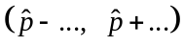.
So for the 95% confidence interval (0.275, 0.395), the sample proportion is
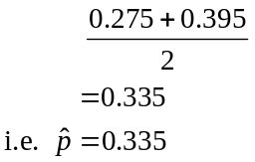
The answer is C.

Question 9
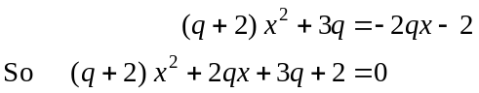
This equation is a quadratic in x.

It will have no real solutions when (that is, the discriminant is less than zero)
i.e 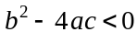 where .

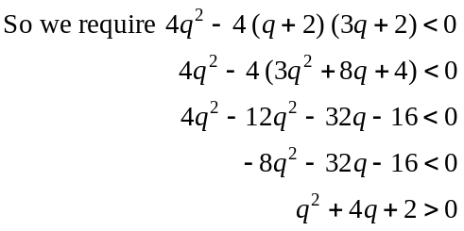
The answer is A.
Question 10
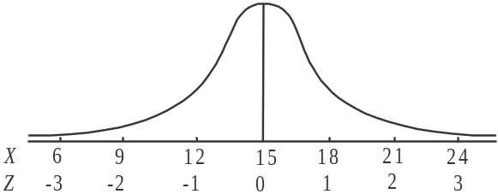
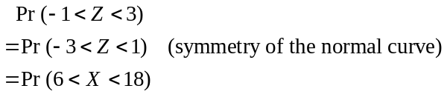
The answer is E.

Question 11

Method 1 – intuitively

The transformation involves
- a reflection in the y-axis
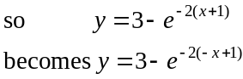
- a translation one unit left
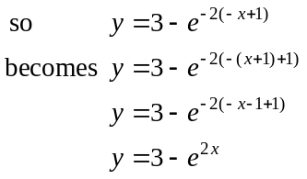
- a translation 3 units down
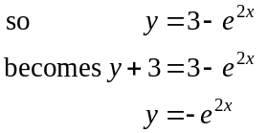
The answer is A.

Method 2 – using matrices

Let 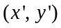 be the image point.
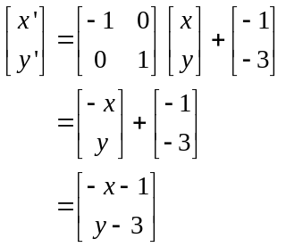
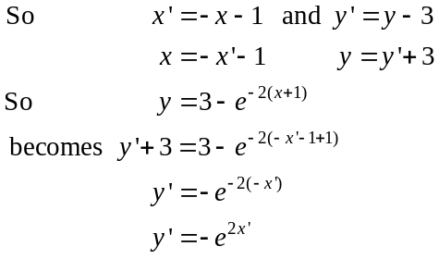
The image equation is 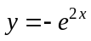.
The answer is A.

Question 12

We are looking to find a horizontal line such that the area above the line between the function f and the boundaries (in this case ) is equal to the area below the line between the function f and the boundaries (in this case ).
The graph below shows these two equal areas which lie above and below the line 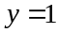.
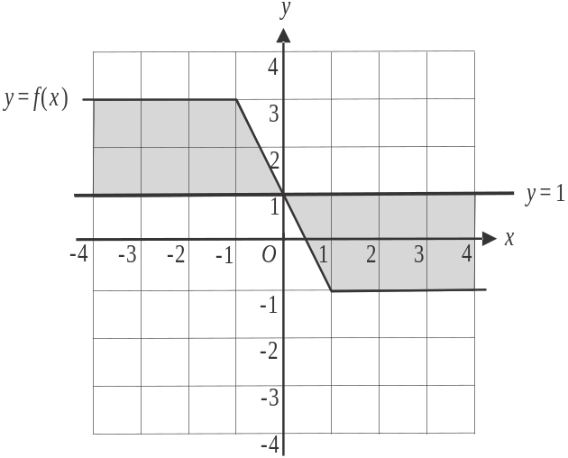

So the average value of f between is 1.
The answer is B.

Question 13

Define g on your CAS.
Key in each of the functional equations starting with option A.
Options A – C are true.
Option D is true for a couple of values of x but is not true for all .
If you have time, key in option E to confirm it is true.
The answer is D.

Question 14

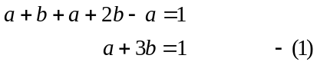
Since 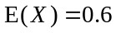,
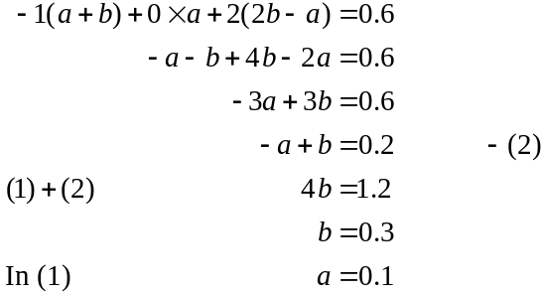
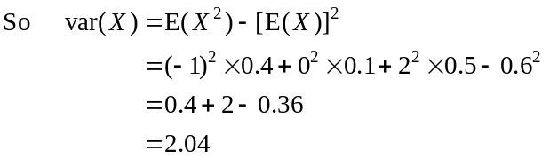
The answer is C.
Question 15

Since the function f is cubic, its derivative function 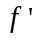 must be quadratic.
Since has an x-intercept at 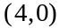 and a turning point at 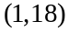, its graph must be an inverted parabola and its other x intercept must be located at 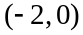.
The equation of is
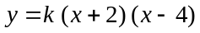.
Substitute in
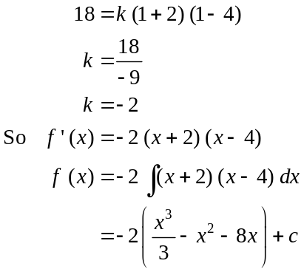
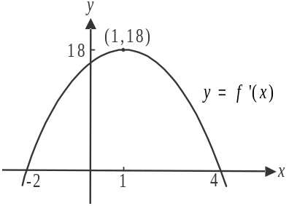
Since f passes through 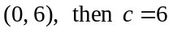.
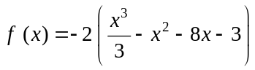
The answer is C.

Question 16

Let 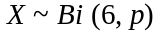 where p is the population proportion.
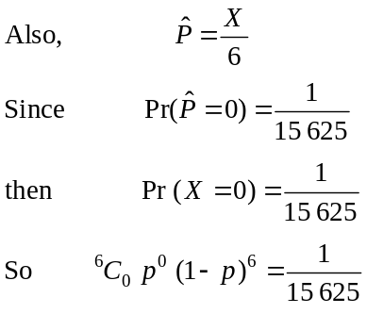
Solve for p using CAS 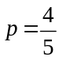, note that 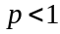.
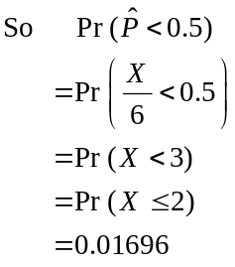
(Note that X can only take integer values i.e. it represents the number of students in a sample of 6 who live at home.)
The closest answer is 0.017.
The answer is A.
Question 17

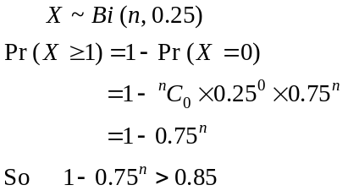
Solve for n, using CAS,
The least (whole) number of games he needs to play is 7.
The answer is B.

Question 18

We have no idea what the function h is and hence no idea what its graph looks like. All we know is that it is above the x-axis between .
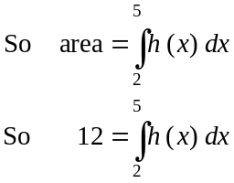
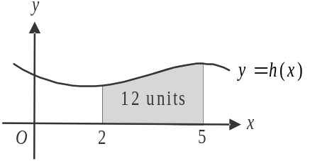

The graph of 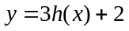 must also lie above the x-axis.
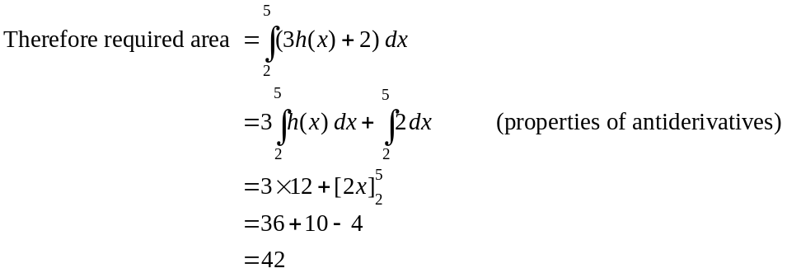
The answer is D.

Question 19

From the graph,
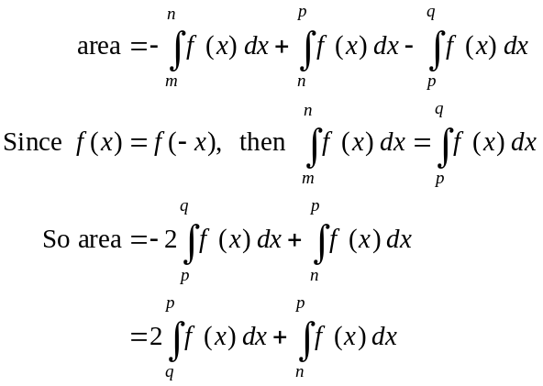
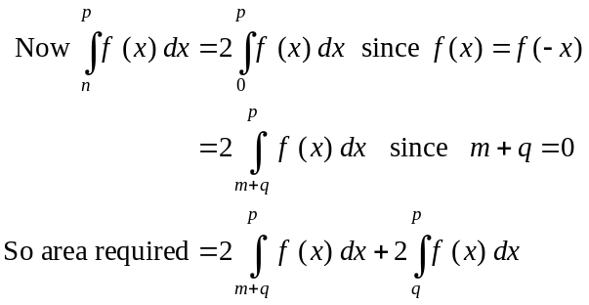
The answer is C.

Question 20

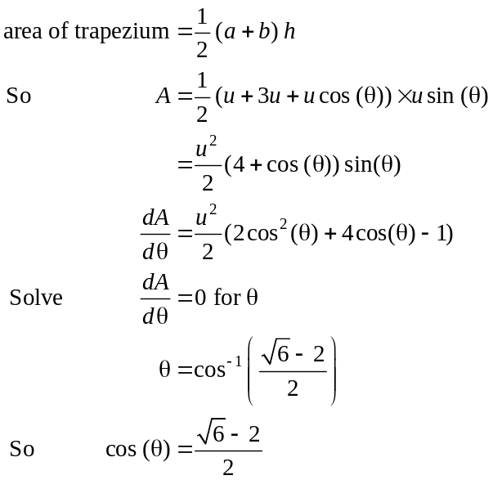
The answer is E.

SECTION B

Question 1 (12 marks)
- Define f on your CAS. Stationary points occur when 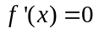.
Solve for x using CAS.
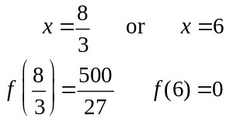
(1 mark)
Stationary points are 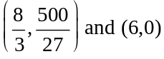. (1 mark)
(Check the graph to make sure these points are feasible.)
- Using the graph and your answer to part a., 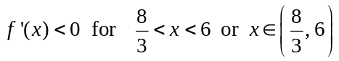.
(1 mark)
- 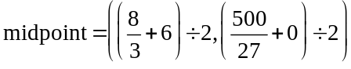
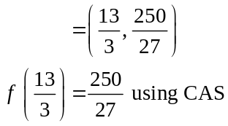
(1 mark)
So the midpoint 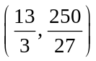 lies on the graph of 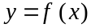. (1 mark)
- i. Define 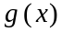 on your CAS.
Define 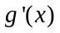 on your CAS.
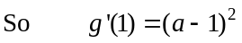
(1 mark)
  - Since 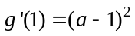, the gradient of the graph of g at the point 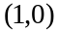 will always be positive if .
Note that if , the gradient will be zero. Because 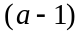 is squared, all other values of a will produce a positive gradient.
So we require 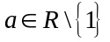. (1 mark)
- Solve 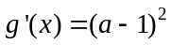 for x (i.e. use your result from part d.i.). (1 mark)
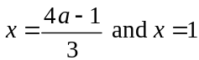
Now 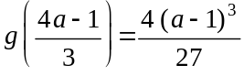
Since P is the point 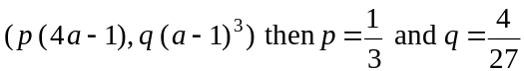. (1 mark)
- The x-intercepts of the graph of g occur at 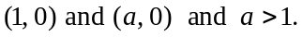
Solve 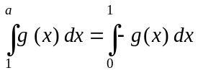 for a.
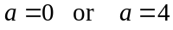
Since 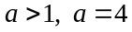. (1 mark) – correct terminals
(1 mark) – correct integrands
(1 mark) – correct answer
Question 2 (16 marks)

- Define 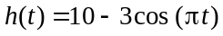 on your CAS.
So 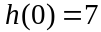
The initial height of L was 7 m above the ground.
(1 mark)

- Method 1

From part a. we see that L is at its minimum height (i.e. 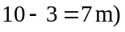 at .
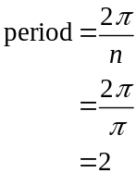
So after 2 minutes L will be at this height again.
(Double check: 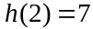)
(1 mark)
Method 2

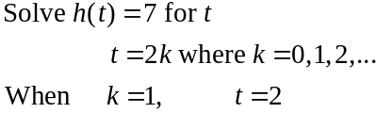
So after 2 minutes L will be at this height again.
(1 mark)

- average rate of change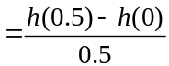 (1 mark)
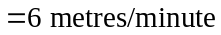
(1 mark)

- 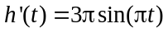. (1 mark)
Since 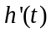 represents the rate of change of h, then it will be a maximum when 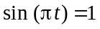.
Solve for t. 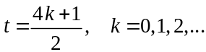
When , 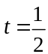
(1 mark)

- 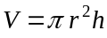 (from the formula sheet) where (from the diagram) and 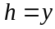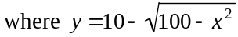.
So 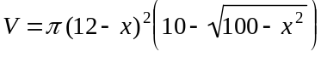 as required.
(1 mark)

- 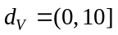
(1 mark)

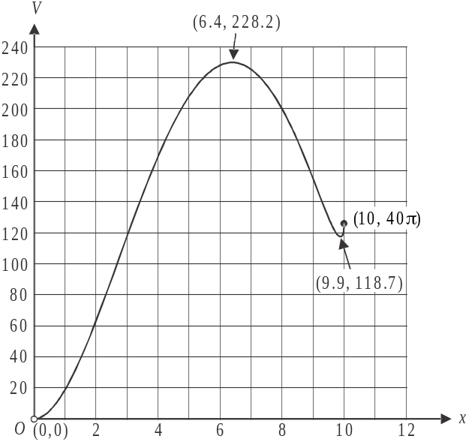

(1 mark) – correct endpoints
(1 mark) – one correct stationary point
(1 mark) – second correct stationary point
- Solve 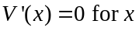.
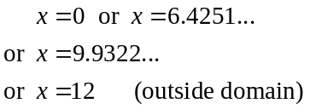
Using our graph from part g. we see that the maximum volume occurs when 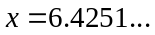
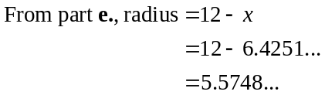
So required radius is 5.57 m.
(1 mark)
- When the volume is a maximum, the point 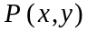 is given by (1 mark)
In the right-angled triangle shown,
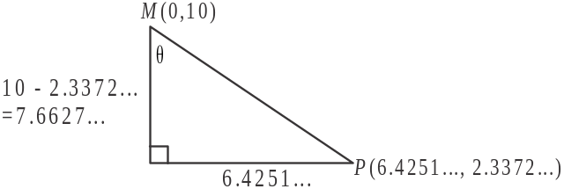
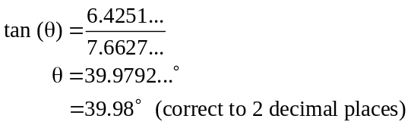
(1 mark)

- From part a., we know that point L was initially at the point 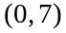, ie 7 m above the ground. It moved 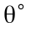 i.e. 39.9792…° anticlockwise, at which time it became parallel to the downpipe represented by MP.
A complete revolution takes 2 minutes (from part b.) so to move through 39.9792…° takes
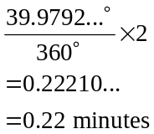
(1 mark)
(1 mark)
Question 3 (17 marks)

- Let X be the charge-time of a model X phone.
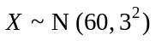
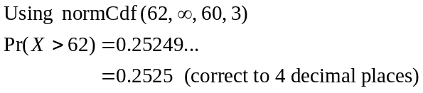
(1 mark)
- 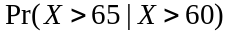 (1 mark)
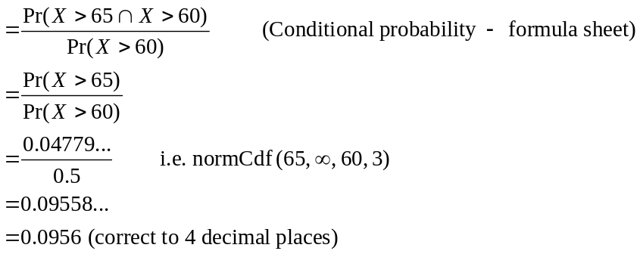
(1 mark)
- Method 1
Let G represent a charge-time of greater than one hour.
(1 mark)
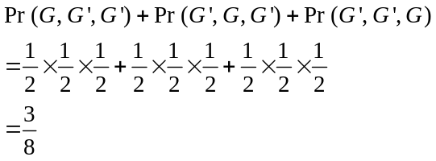
(1 mark)
Method 2
Let H represent the number of model X phones selected with a charge time greater than one hour. So 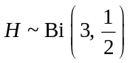. (1 mark)
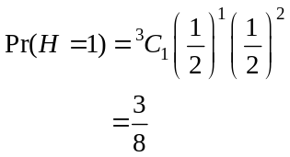
(1 mark)
- Let Y represent the number of these 32 model Y phones sold on day 1 which have a charge-time greater than one hour.
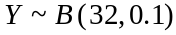 (1 mark)
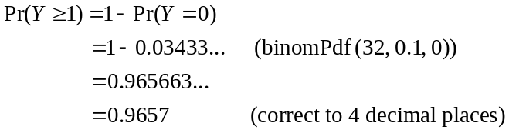
(1 mark)
- 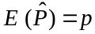 (i.e. the population proportion)
(1 mark)
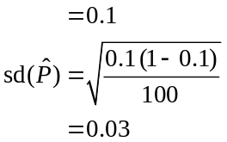
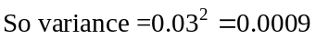 (1 mark)
- Let 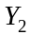 represent the number of model Y phones with a charge-time greater than one hour for these samples of 100 phones.
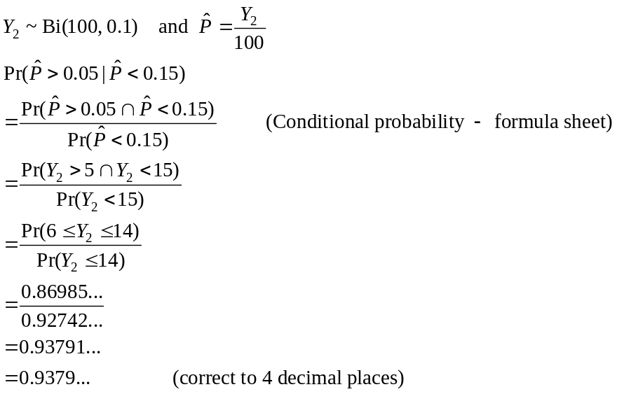
(1 mark)
(1 mark)
(Remember that is a proportion and represents integer values, i.e. the number of phones)
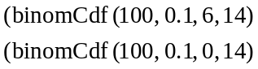
(1 mark)

- 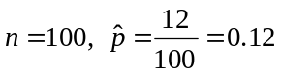
Using CAS, 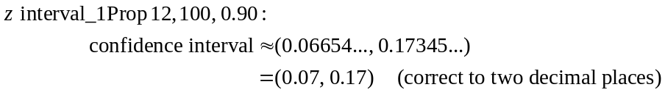
(1 mark)

- We know from earlier parts in the question that 50% of model X phones have a charge-time greater than one hour and 10% of model Y phones have a charge-time greater than one hour.
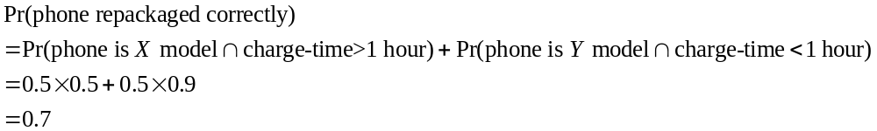
(1 mark)
(1 mark)

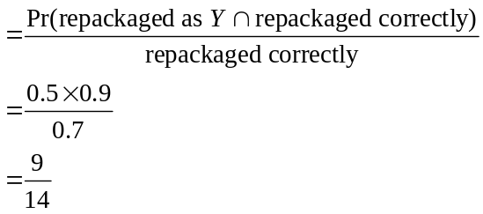
(1 mark)
(1 mark)

Question 4 (15 marks)

- 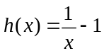
Let 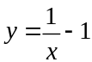
Swap x and y for inverse.
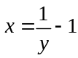
Method 1 – using CAS
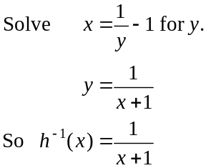
(1 mark)

Method 2 – by hand
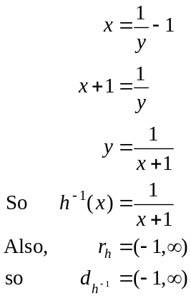
(1 mark)
(1 mark)
- i. Solve 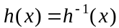 for x.
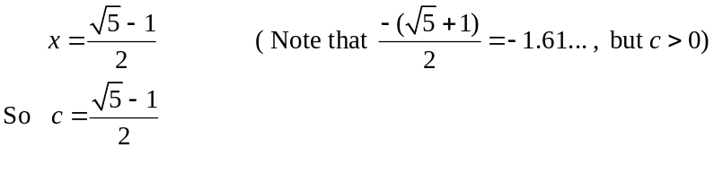
(1 mark)
  - 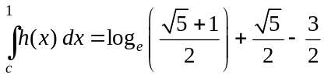 (1 mark)
An alternate and correct answer is 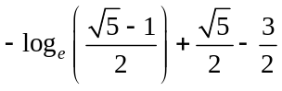.
  - 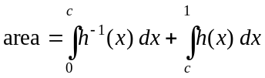 (1 mark)
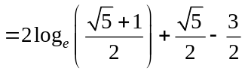 square units (1 mark)
c. i. Method 1 - intuitively
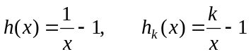
In the matrix equation, d is the factor by which the graph of h is dilated from the y-axis to give the graph of 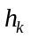. So .
(1 mark)
Method 2
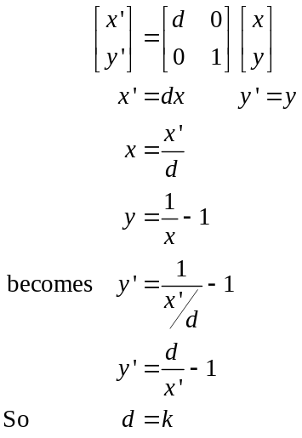
(1 mark)

- T describes a dilation by a factor of k from the y-axis.
(1 mark)

- 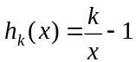
Let 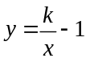
Swap x and y for inverse
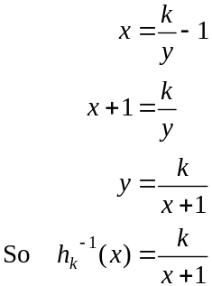
(1 mark)

- 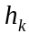 crosses x-axis at 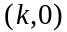
Using CAS, 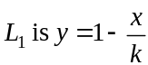.
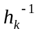 crosses y-axis at 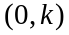.
Using CAS, 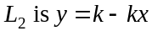. (1 mark)
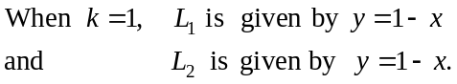
Have shown.
(1 mark)
- From part e., we know that , since 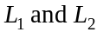 are the same line when but for other values of k this will not be the case as shown in the diagram below.
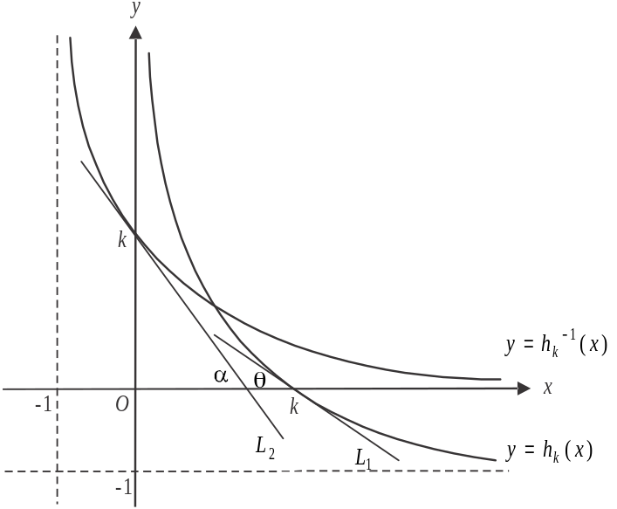

Gradient of 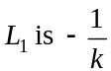.
Gradient of 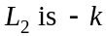.
When 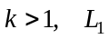 will be less steep than 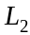, so (as seen in diagram).
When 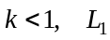 will be steeper than 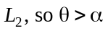.
Also (given in question).
So .
(1 mark) – left endpoint
(1 mark) – right endpoint

- i. Note that the function p gives the vertical distance between the functions
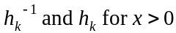.
Define p on your CAS.
Solve 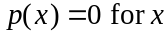
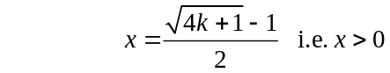
Since 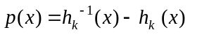, this tells us that 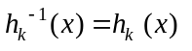 when 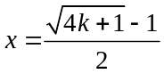.
Using the graph we see that 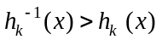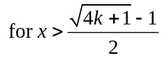.
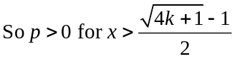
(1 mark)

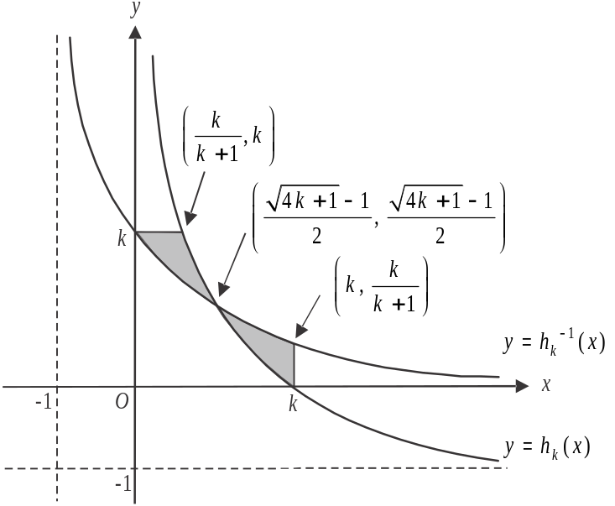

The two shaded regions in the graph above must be equal because of the symmetry of the inverse functions around the line .
So the shaded region on the left which is the required area, ie the area enclosed by the graphs of 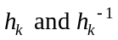 and the line 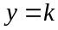, equals the shaded region on the right.
So the required area is given by 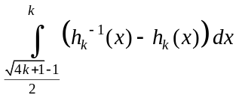.
Since the definite integral asked for must involve p, we can express the required area as 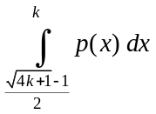.
(1 mark)

